**Lab1**

**(1) Create Database**

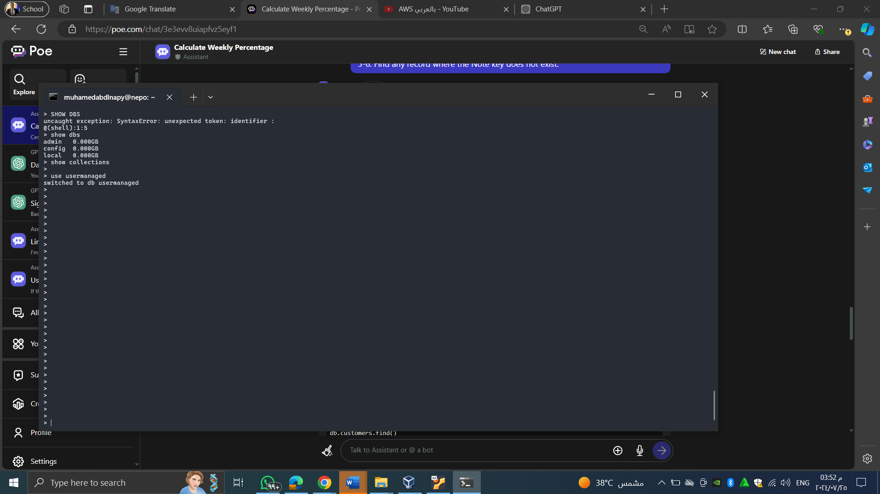

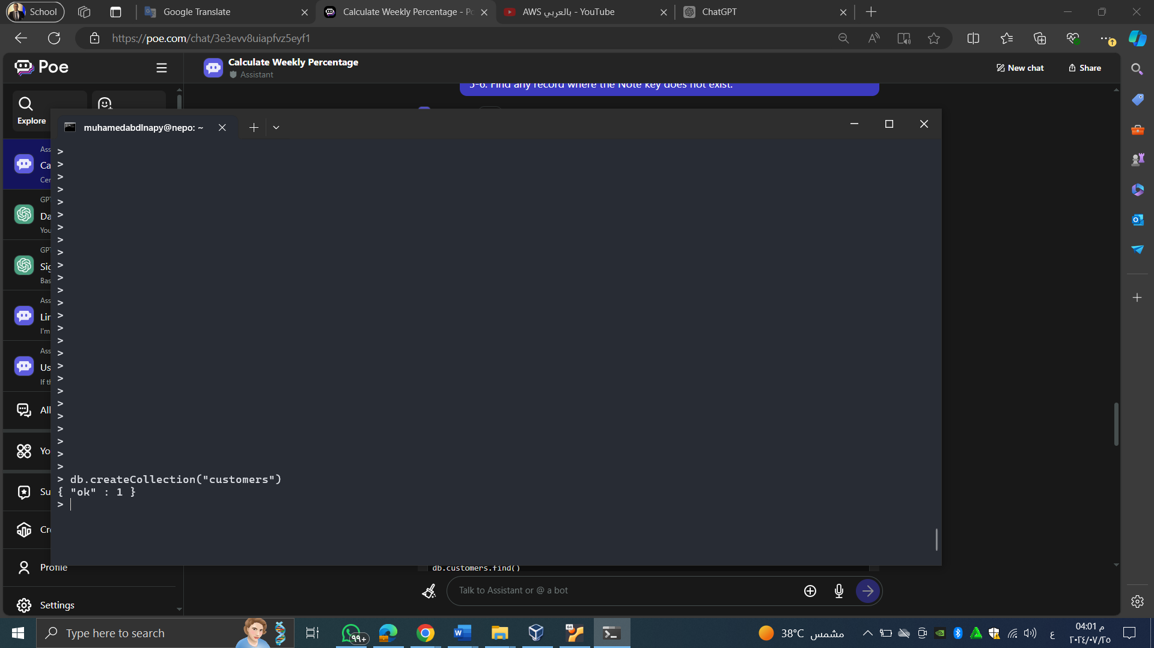

**(2) Create a Collection & Insert a Record**

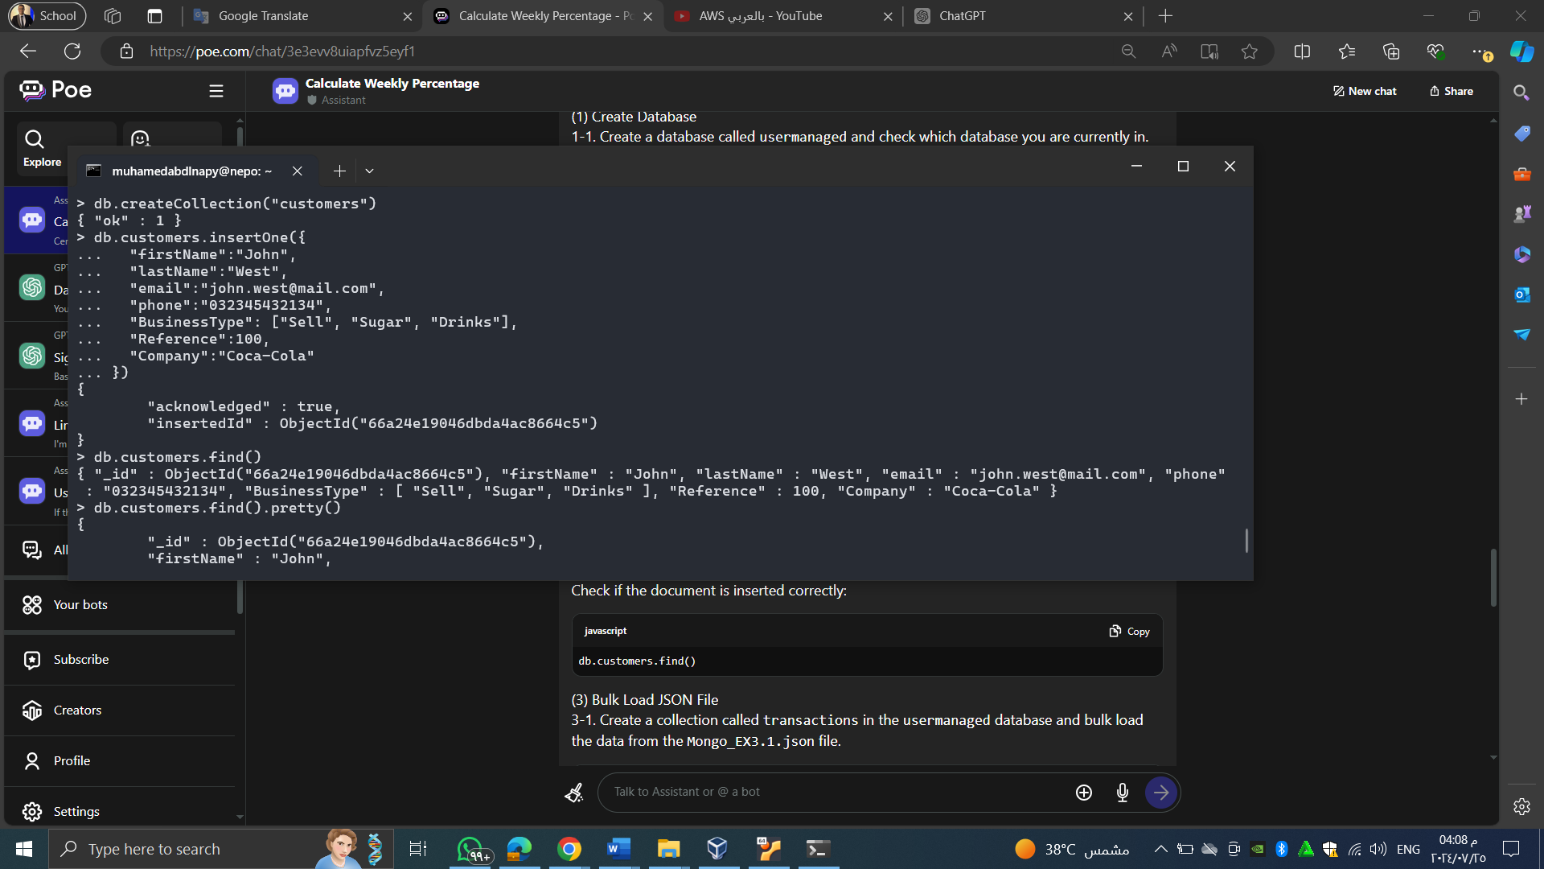

**(3) Bulk Load JSON File**

3-1. Create a collection called transactions in usermanaged ,bulk load the data from a json file(import Mongo_EX3.1.json).

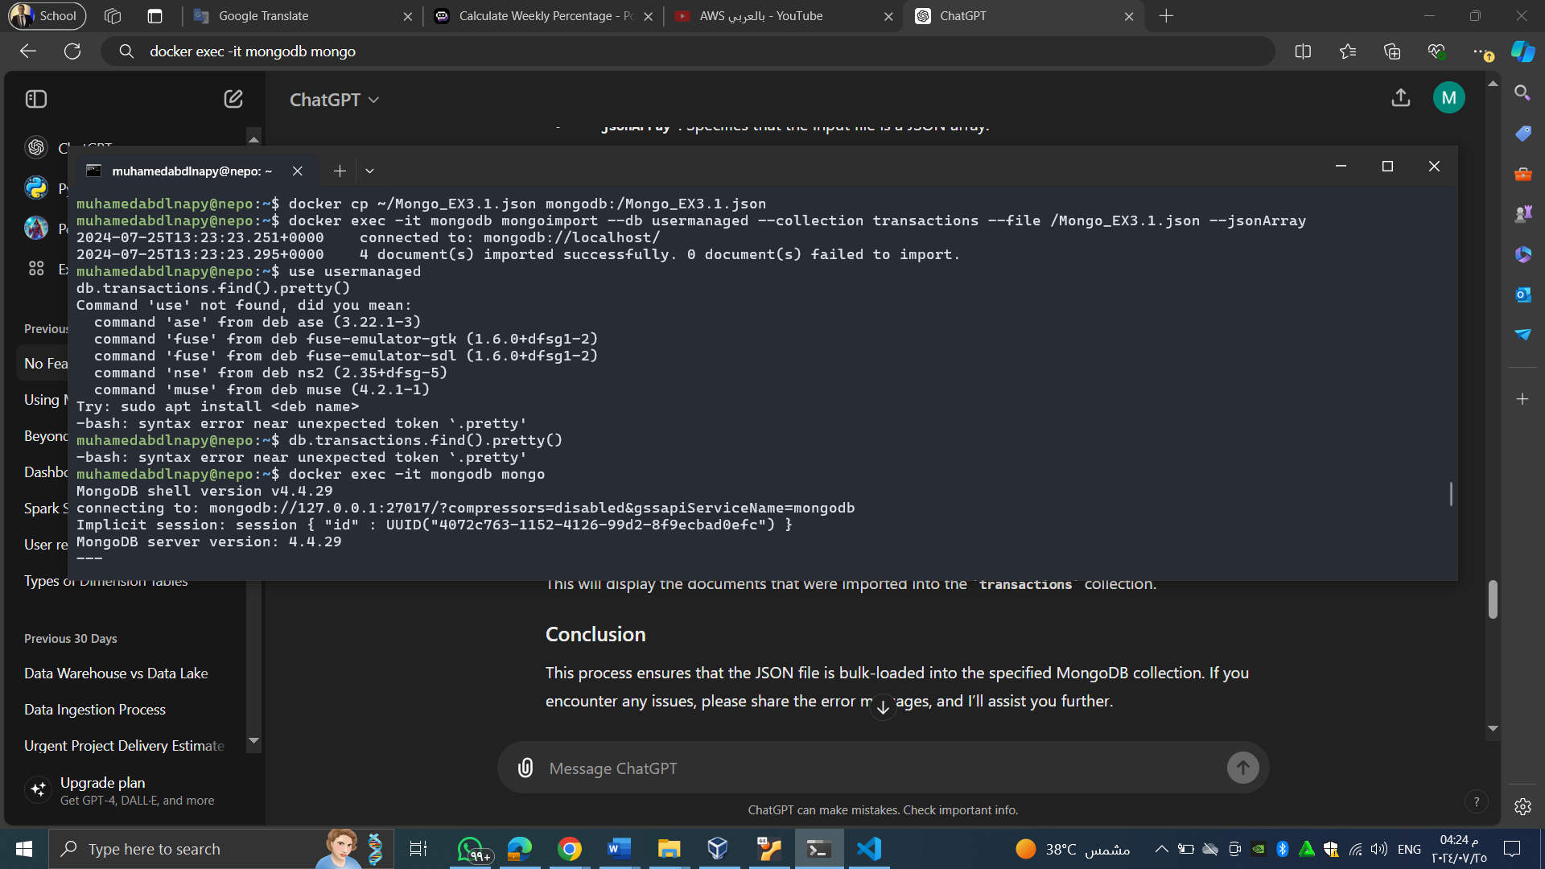

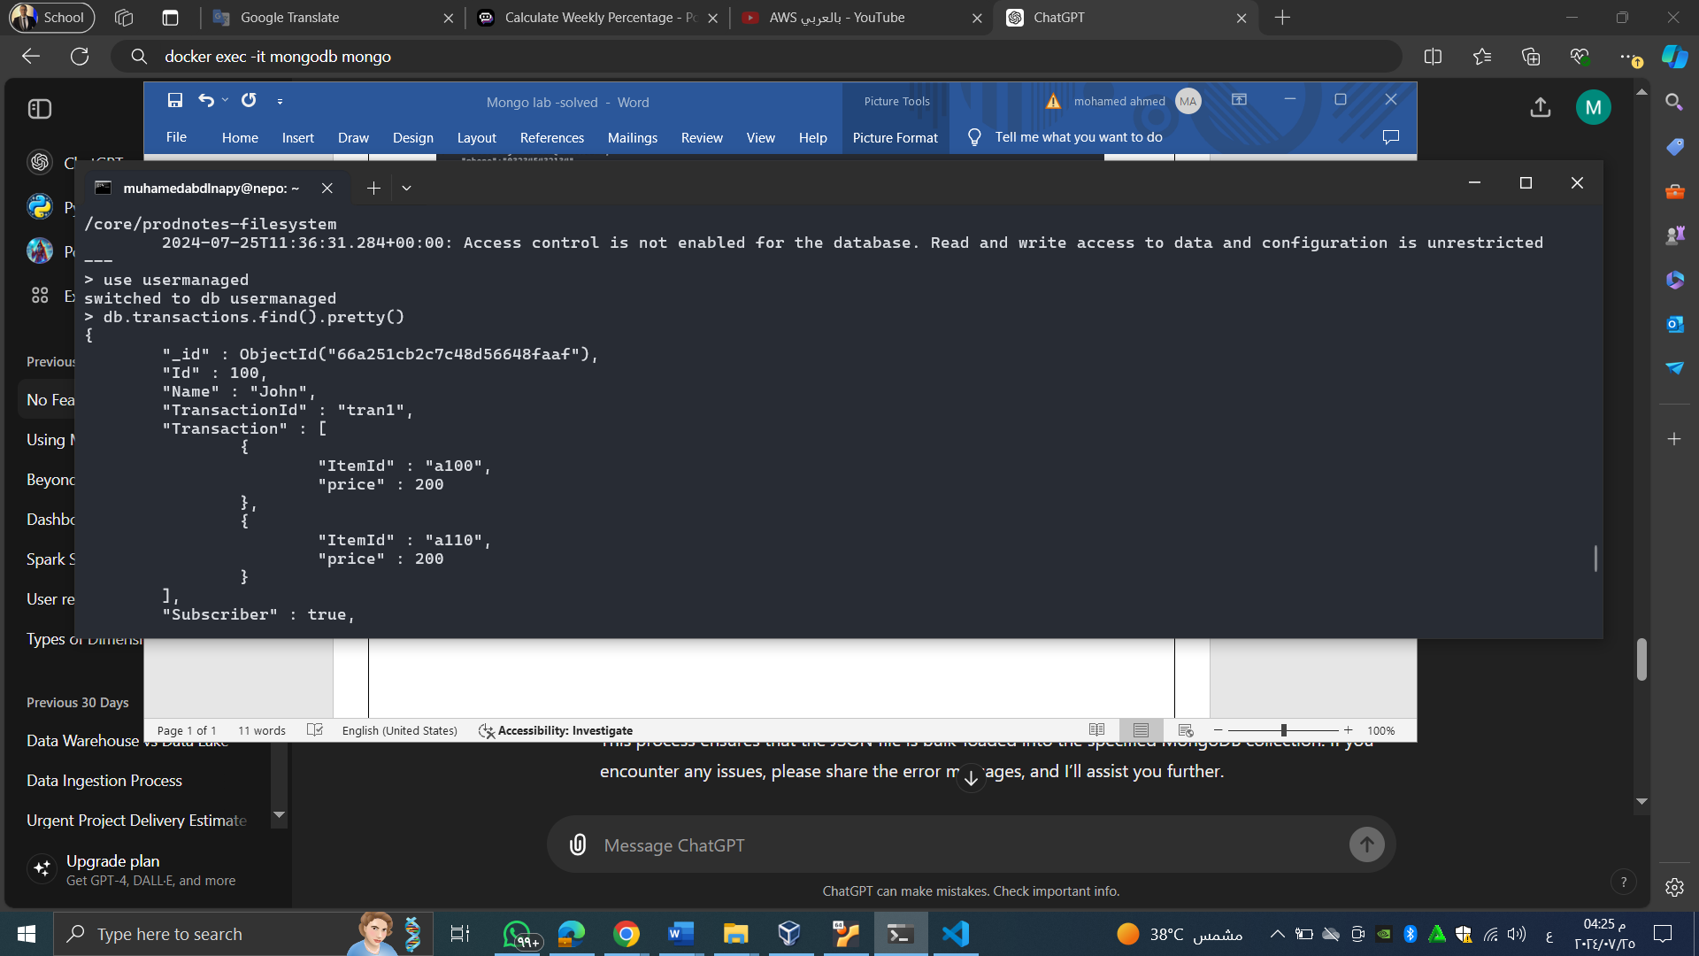

**3-3. Upsert the record from the new (import Mongo_EX3.3.json)**

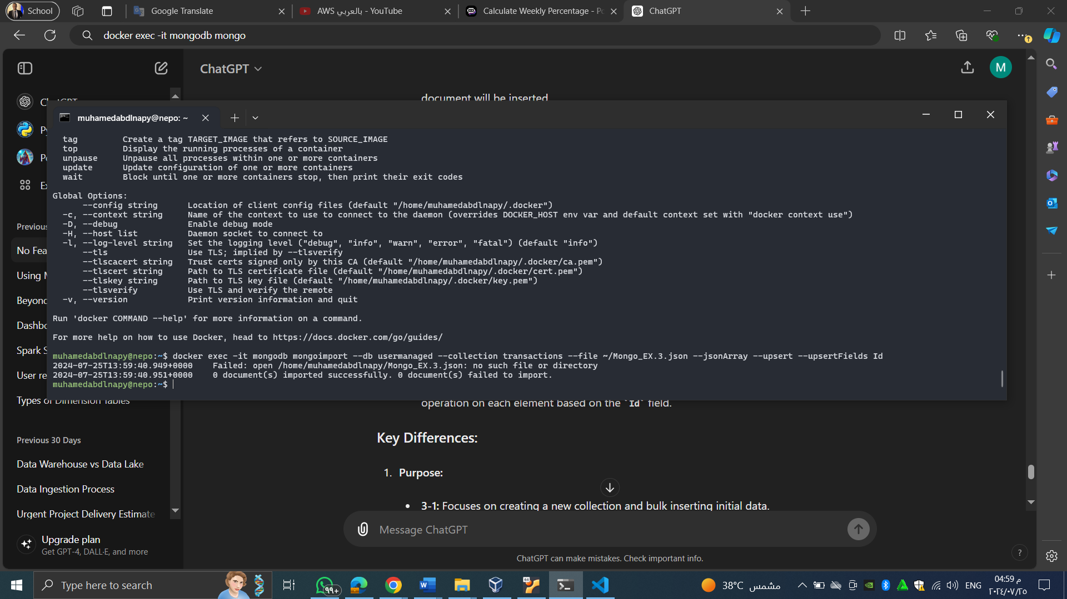

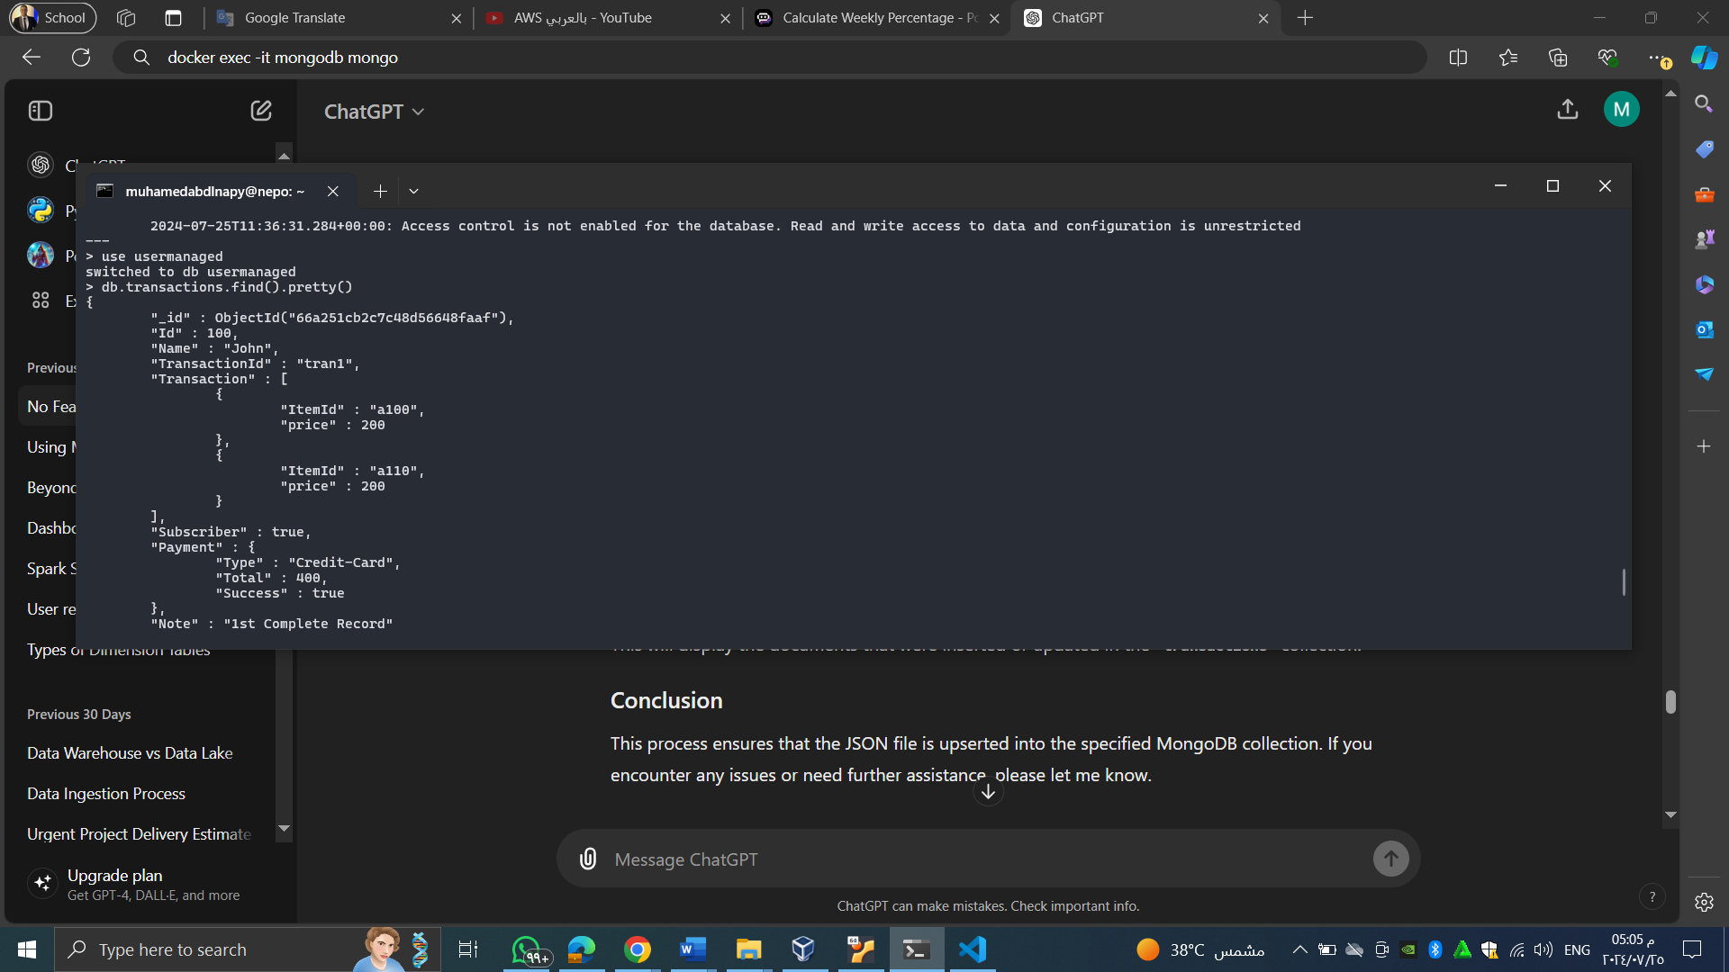

**(4) Bulk Load CSV File**

4-1. Create a collection and load data from a CSV file will multiple rows. Define the keys from the header row.

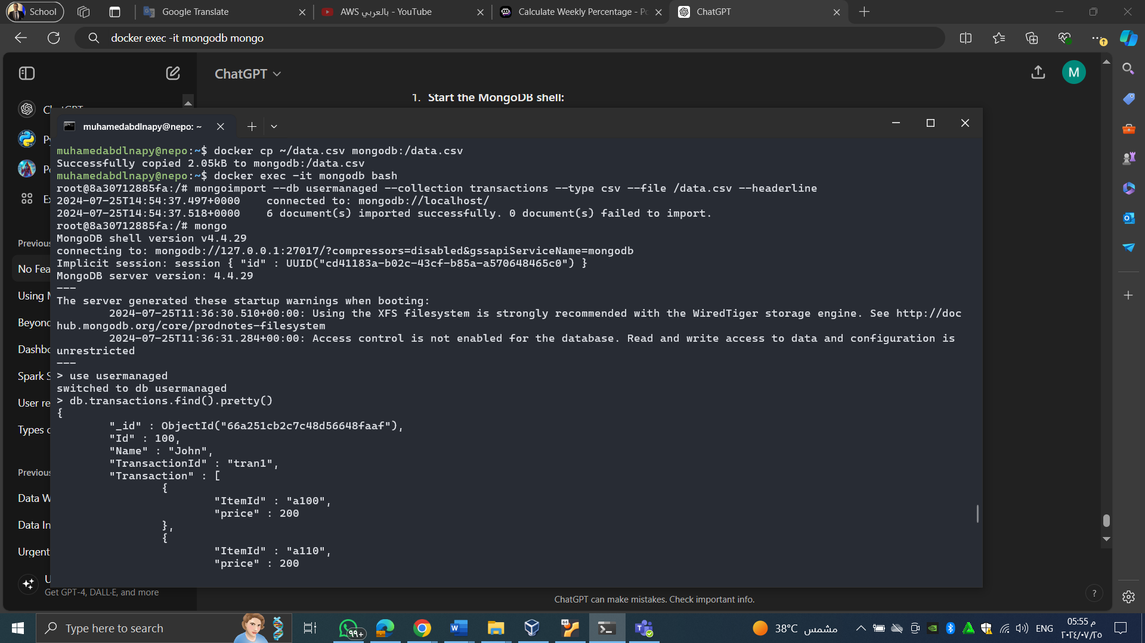

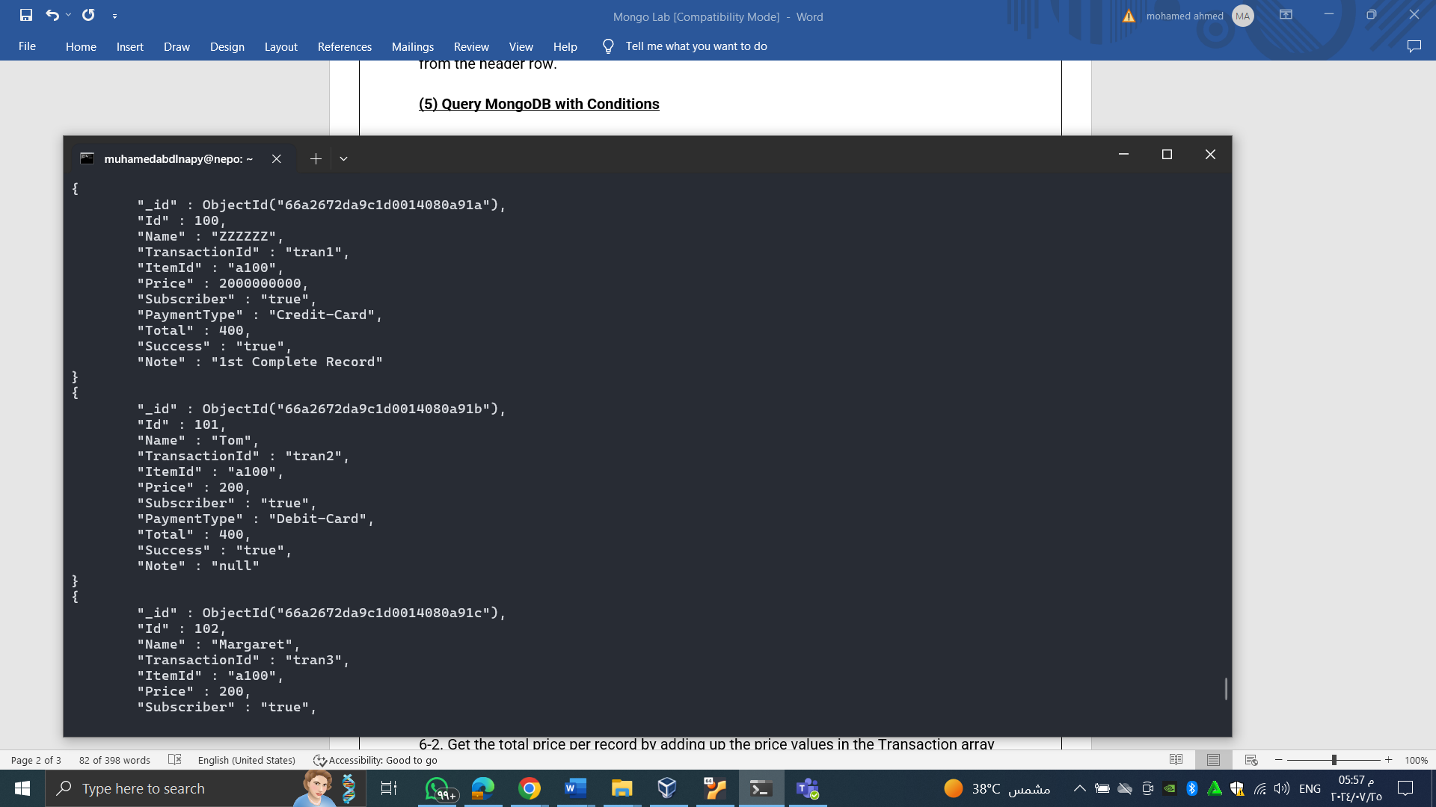

**(5) Query MongoDB with Conditions**

This question uses the collection (transactions) created in Exercise 3.

5-1. Find any record where Name is Tom

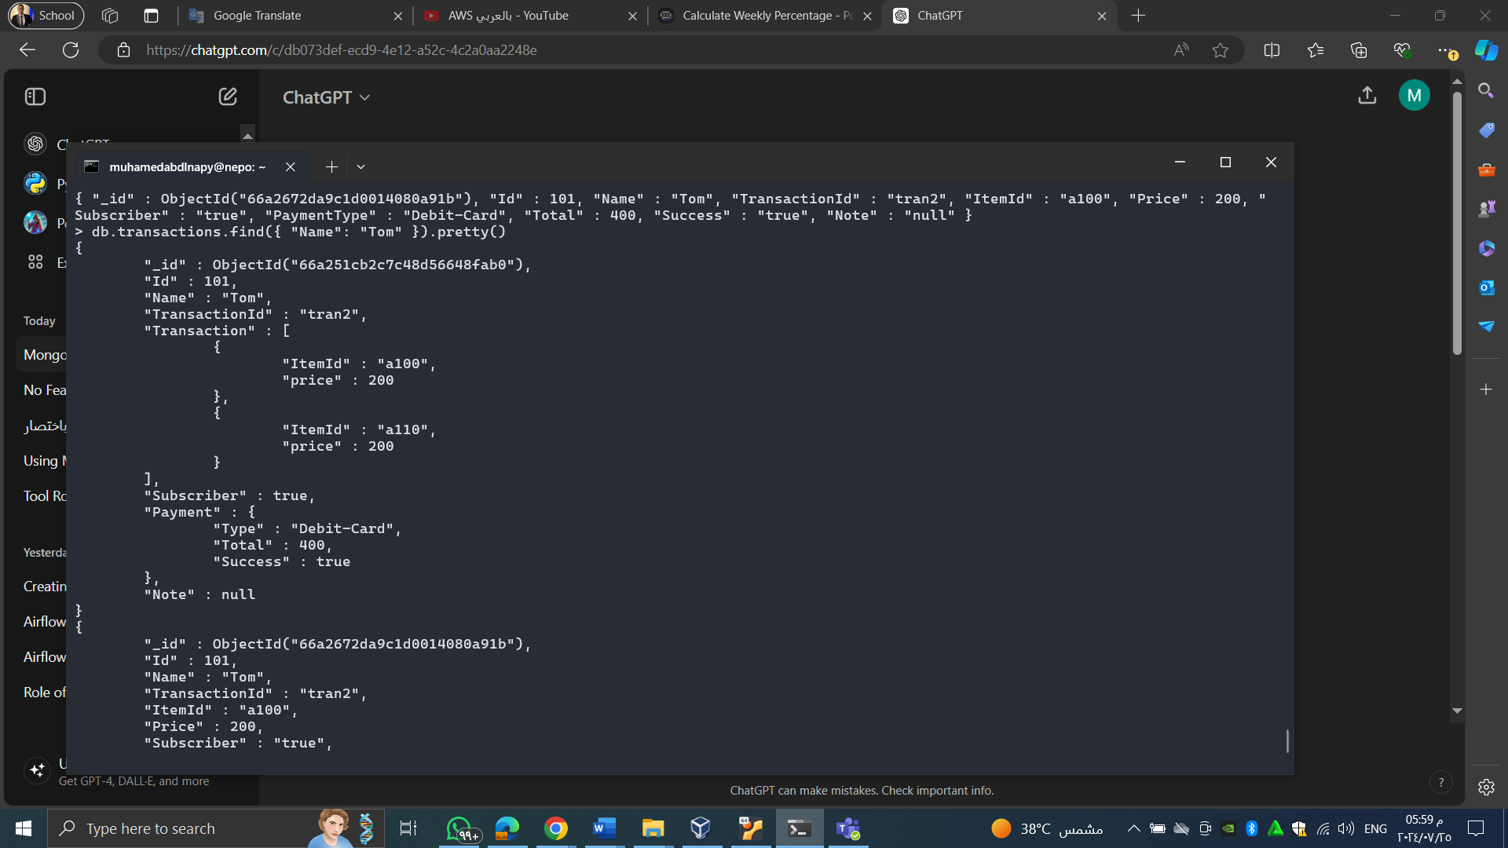

5-2. Find any record where total payment amount (Payment.Total) is 400.

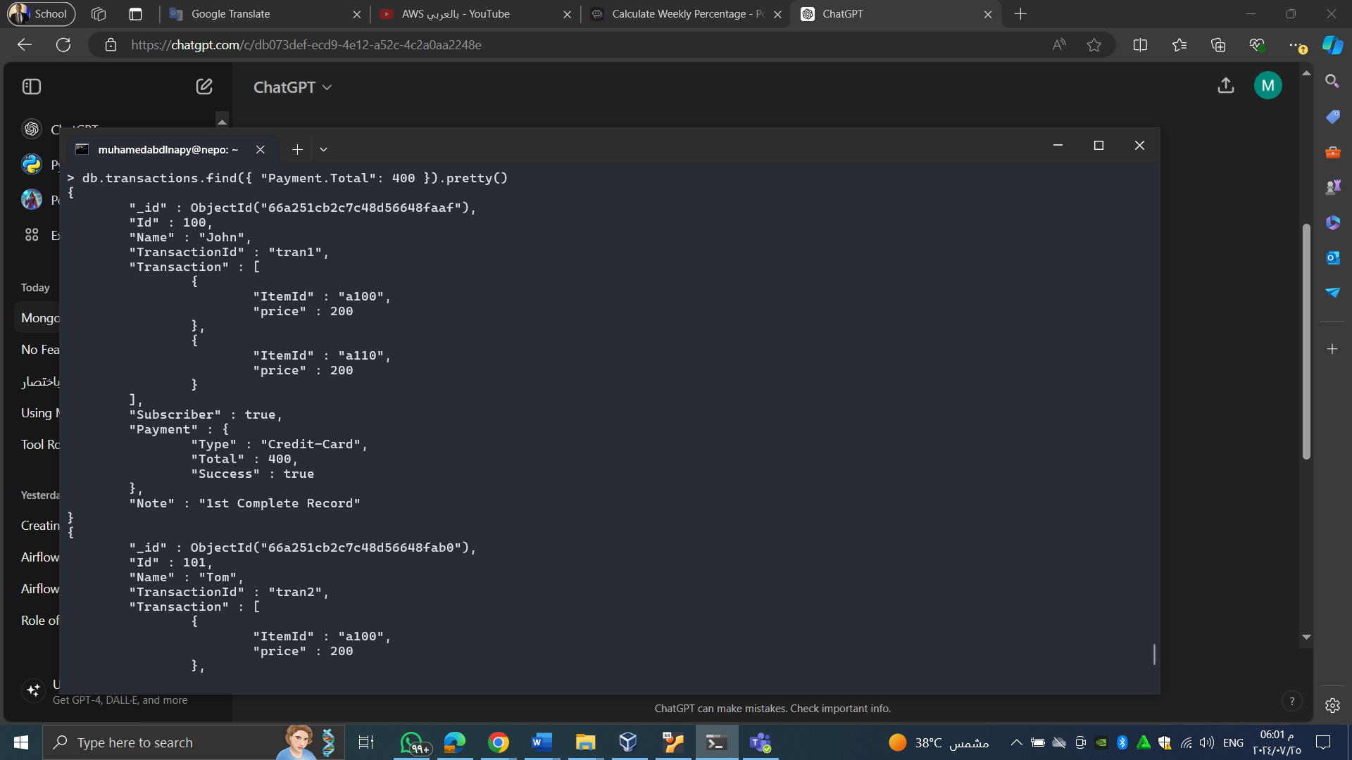

5-3. Find any record where price (Transaction.price) is greater than 400.

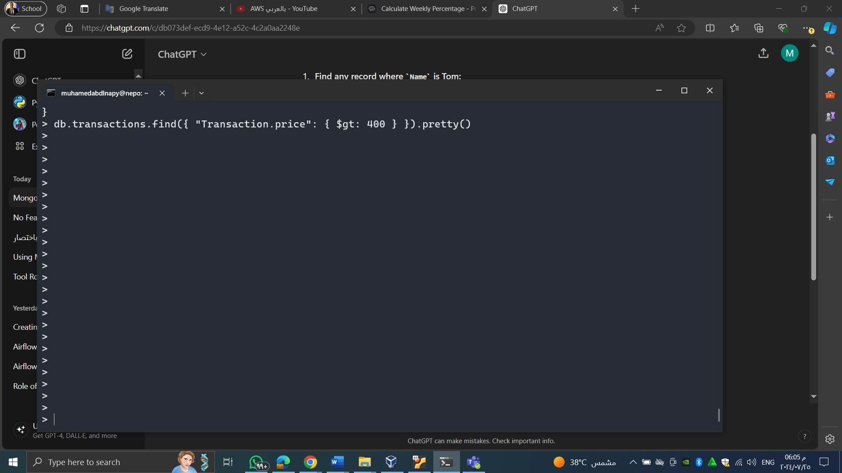

5-4. Find any record where Note iwqs null or the key itself is missing.

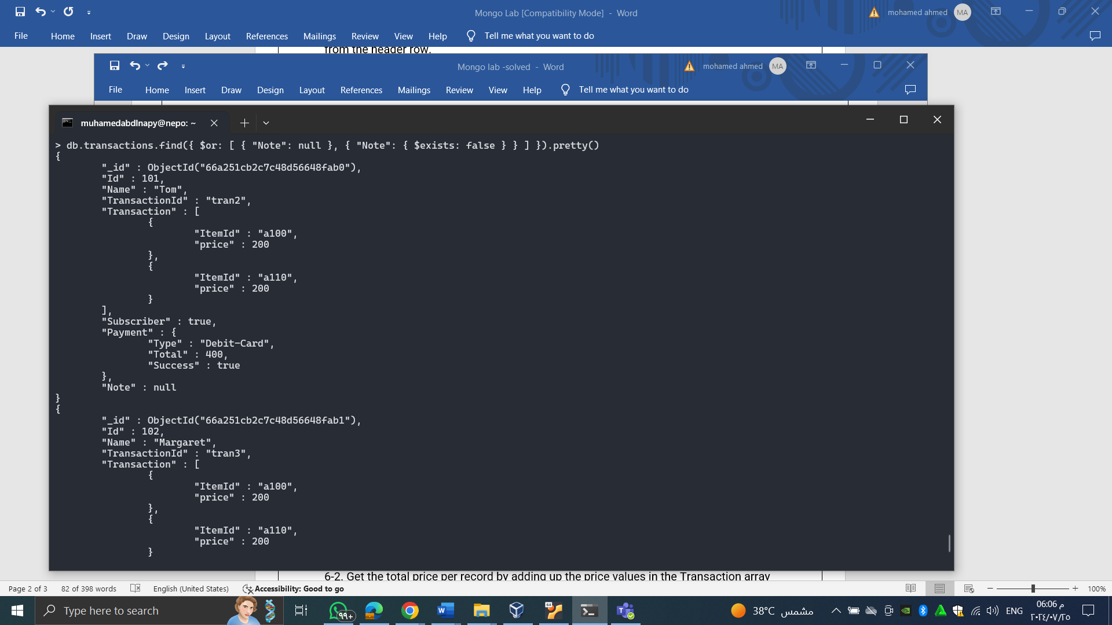

5-5. Find any record where Note exists and its value is null.

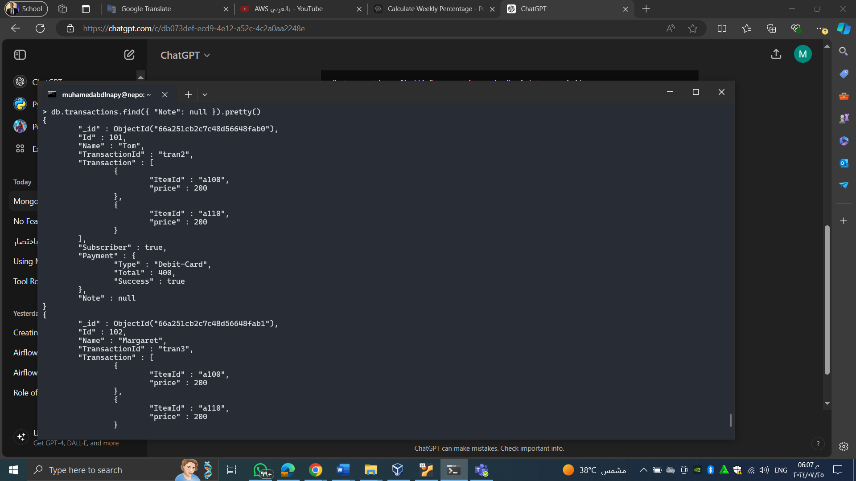

5-6. Find any record where the Note key does not exist.

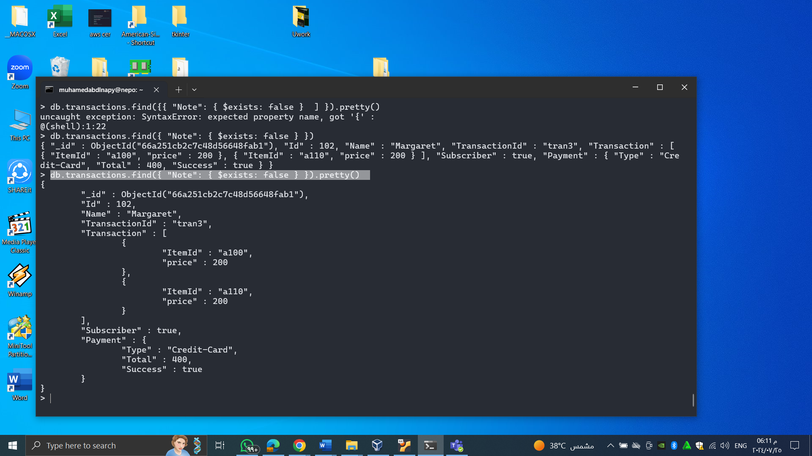

**6) Aggregation with MongoDB**

6-1. Calculate the total transaction amount by adding up Payment.Total in all records.

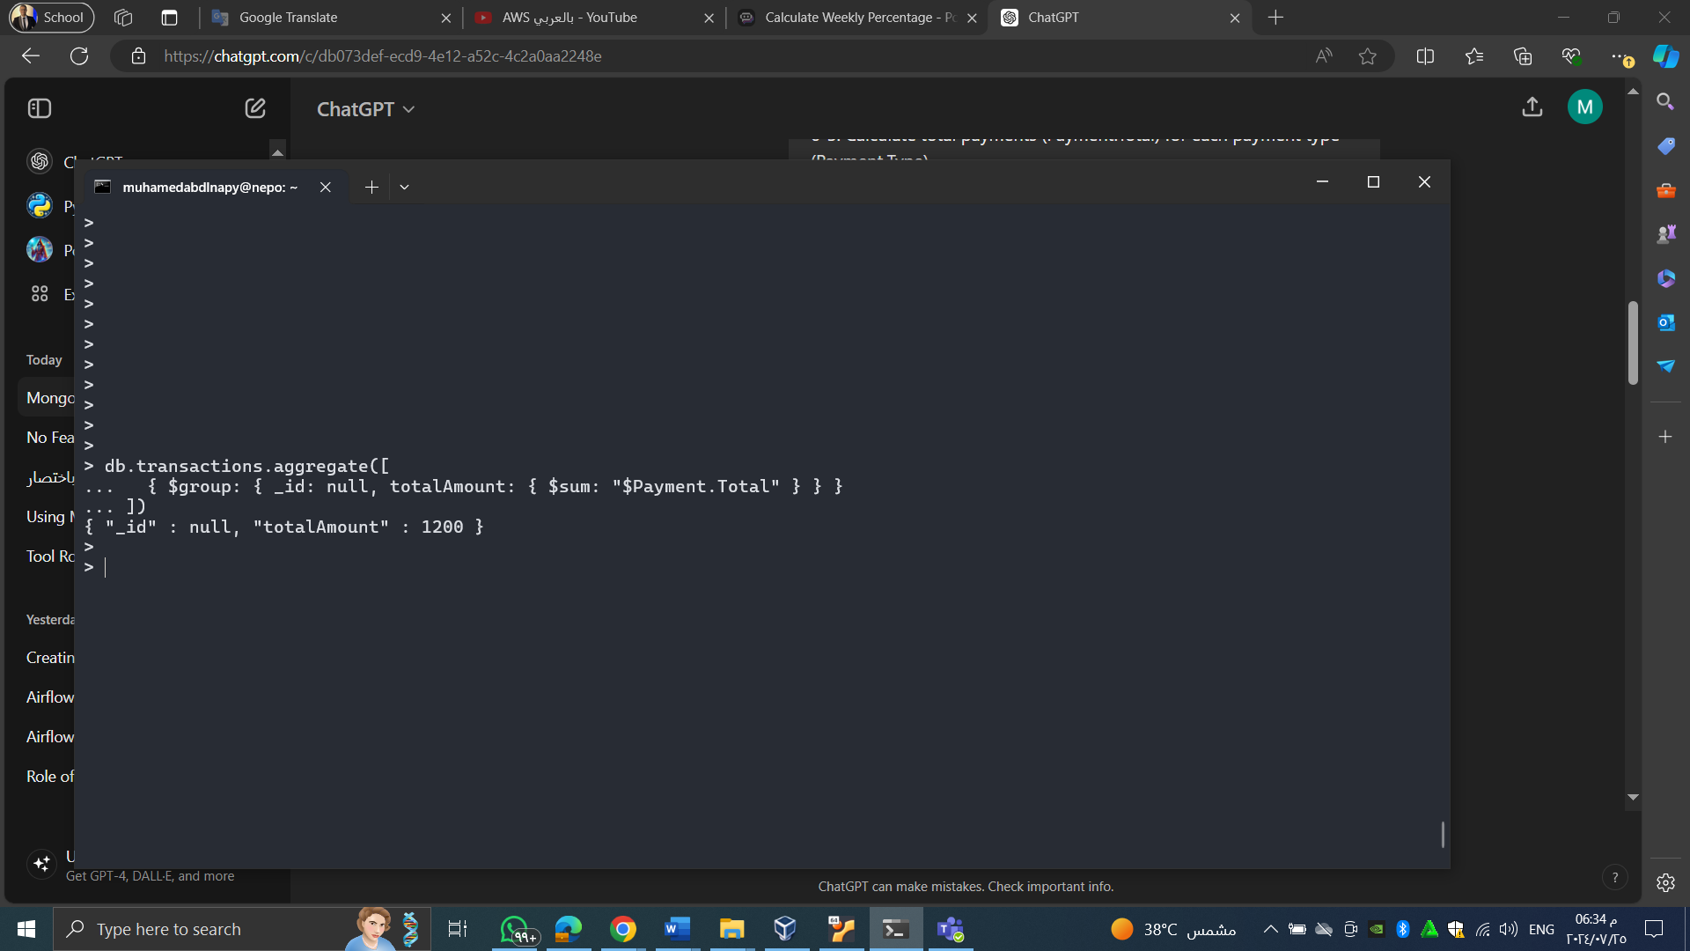

6-2. Get the total price per record by adding up the price values in the Transaction array (Transaction.price).

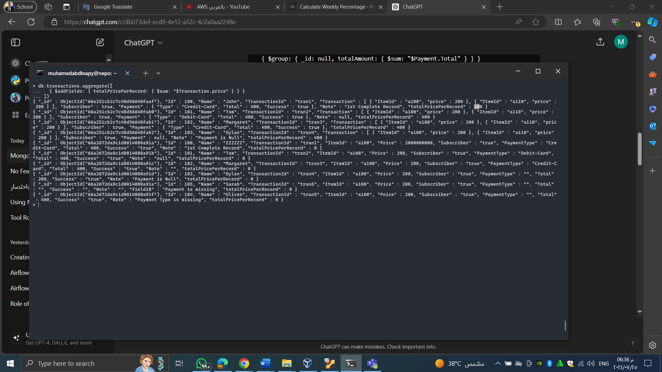

6-3. Calculate total payments (Payment.Total) for each payment type (Payment.Type).

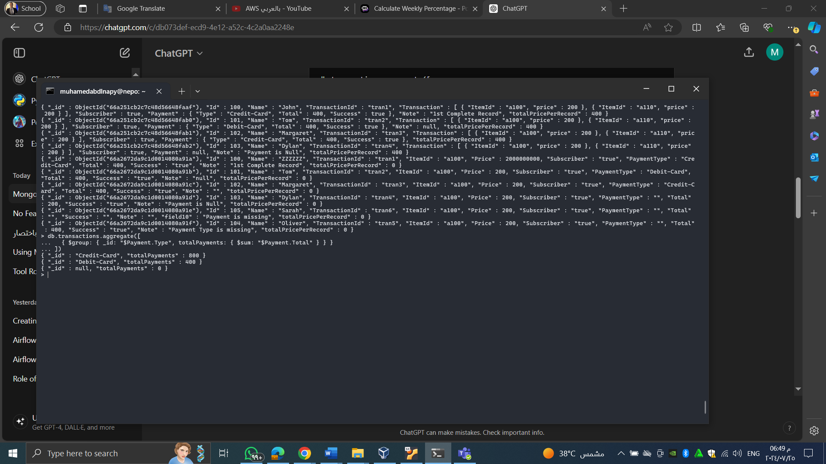

6-4. Find the max Id.

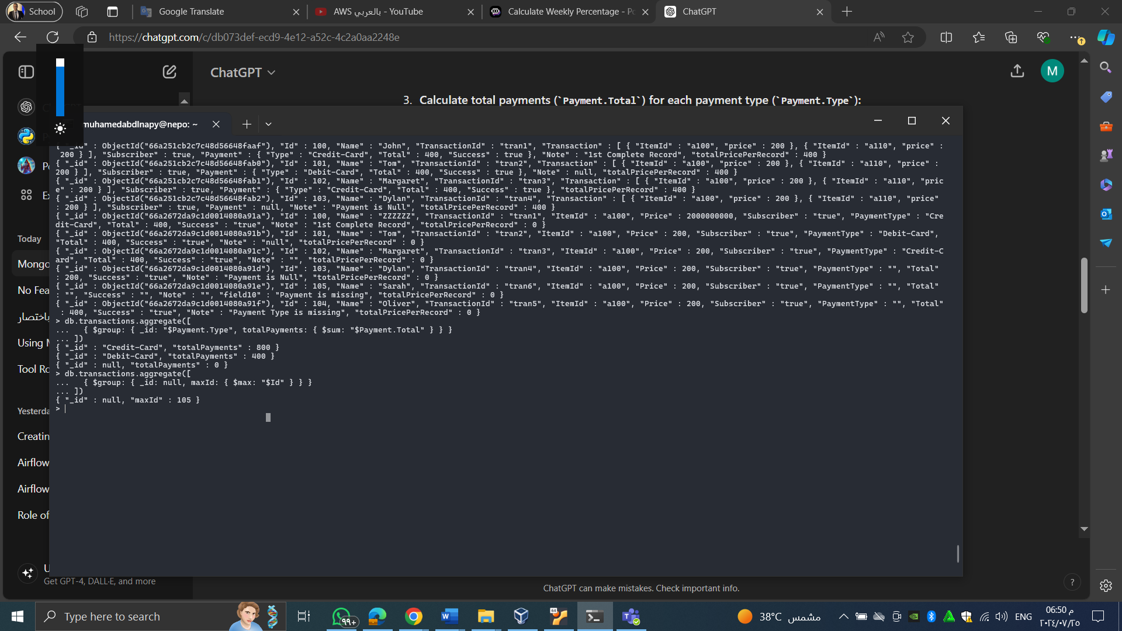

6-5. Find the max price (Transaction.price).

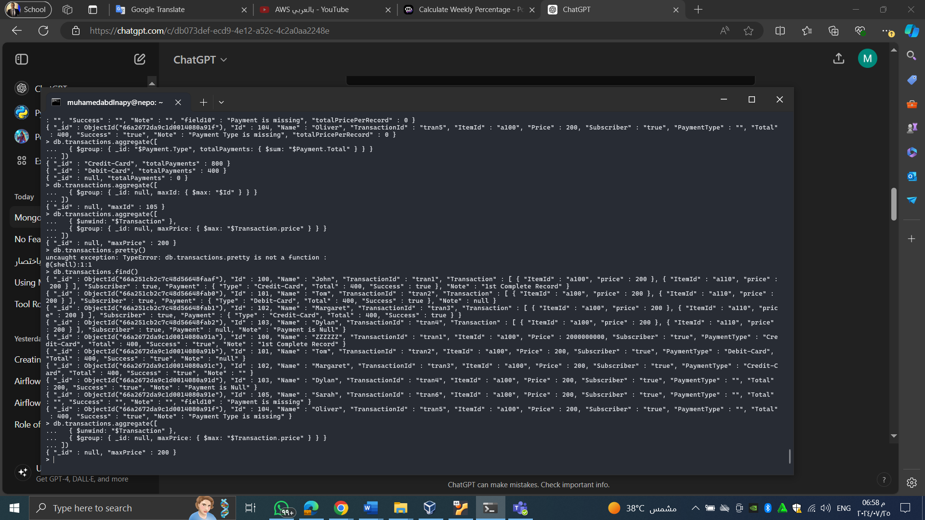

**(7) CRUD Operations**

This question uses the collection (transactions)that created in Exercise 3.

7-1. Insert a record below

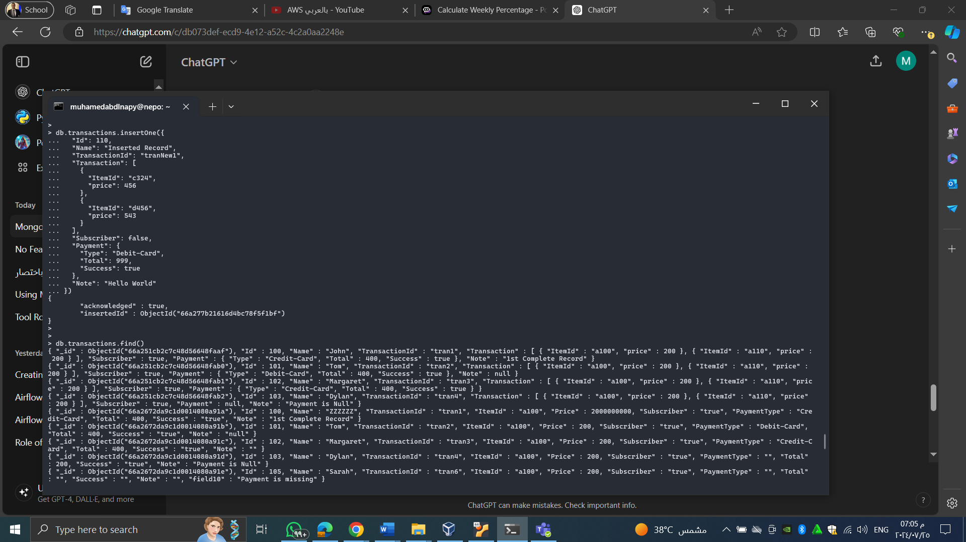

**7-2. Updating the new inserted record above. Make Name=’Updated Record’ & Note=’Updated!’**

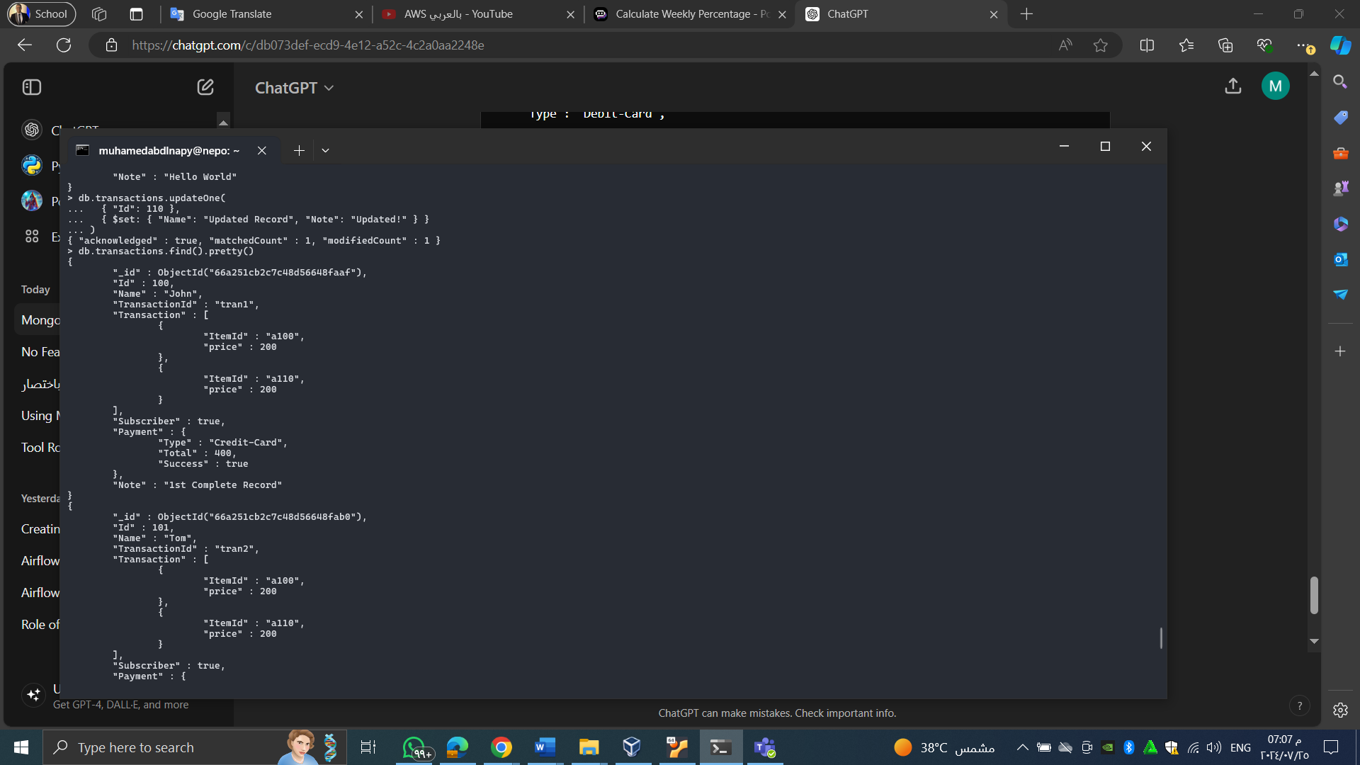

**7-3. Delete the record inserted above by using Id**

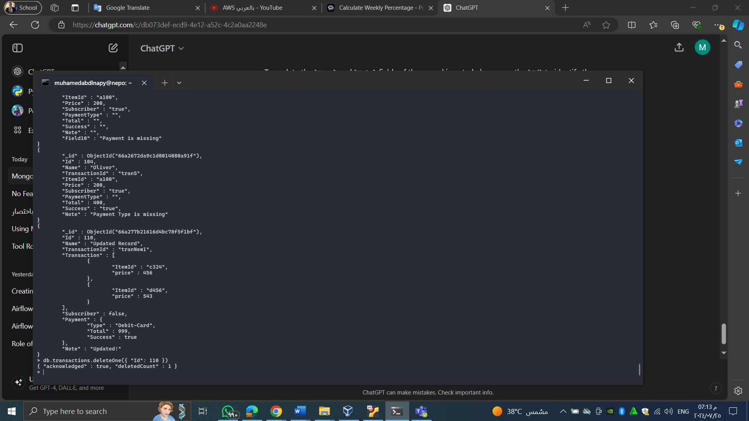

**(8) User Creation**

8-1. Create a read only user who can query records from collections from all databases.

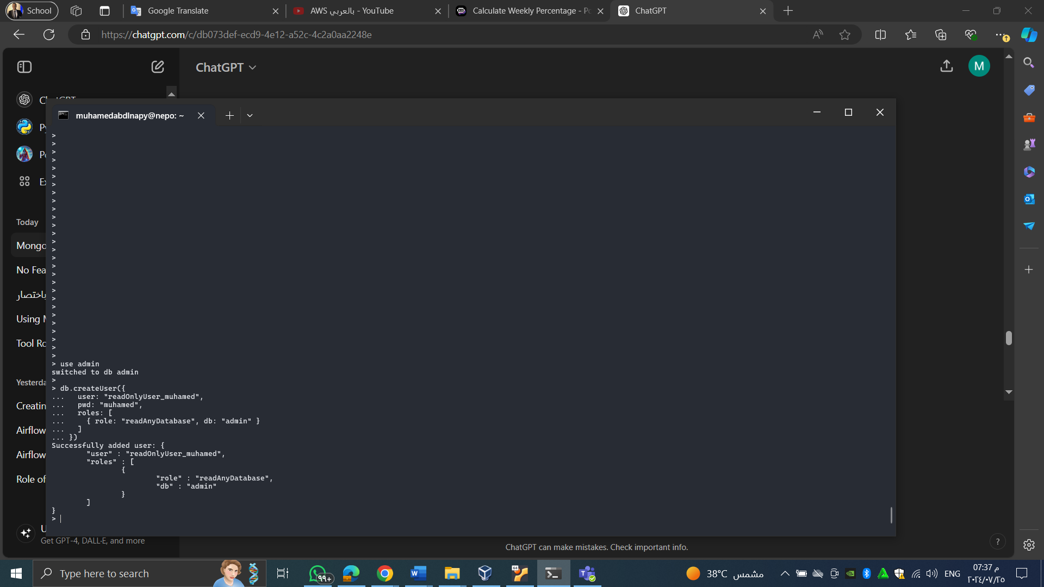

8-2. Create a writer user who can create collections and do CRUD operations in any collections.

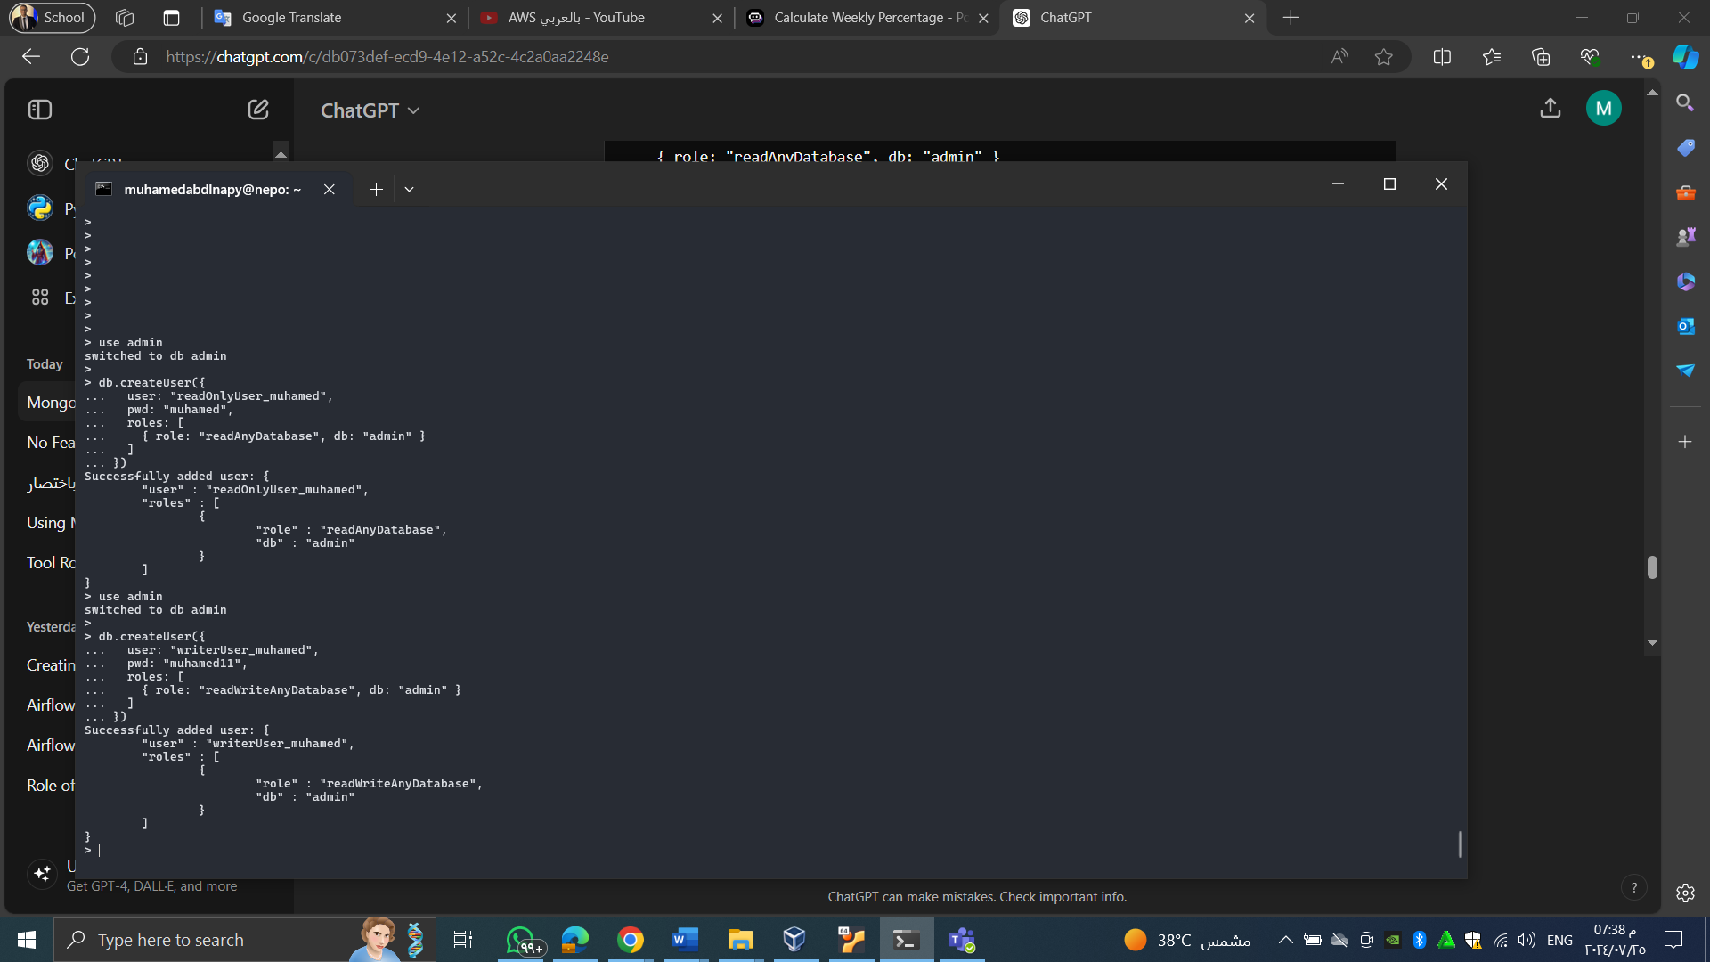

8-3. Create a usermanaged user who can do the writer operation in the usermanaged database and read only for the rest of the databases.

